Dominic Bumpus Algo Project 1 Report

What is program about:
The Program itself is meant to sort addresses in the order as required: State, Zip, City, Street Address, First Name, and finally Last Name.
What algorithms were used:
The two algorithms used for sorting in the program is Quick Sort and Merge Sort
Table showing execution time of each algorithm per file:
 | 100 | 200 | 1000 | 5000
Quick Sort | 199ms | 424ms | 13,611ms | 121,881ms
Merge Sort | 485ms | 1026ms | 12,285ms | 136,002ms

Performance Graph (Run Time vs Input):
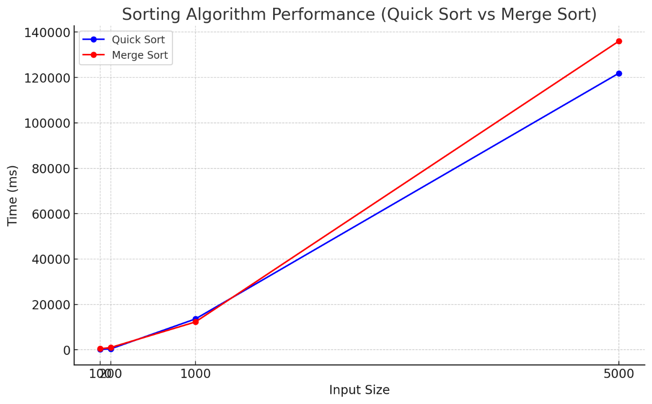
Time Complexity of Program:
Quick Sort:
Average Case: O(nlogn)
Worst Case: O(n^2)
Merge Sort:
Best Case: O(nlogn)
Worst Case: O(nlogn)

